CS4186 Computer Vision & Image Processing

Assignment 1

SHYLA KUMAR Rohit (54581876)

# Part 1

## A. Filter Bank

Below are visualizations of the 48 filters as specified in the assignment description with captions to indicate details of each specific set of filters.

4 Gaussian filters with in increasing order from left to right.

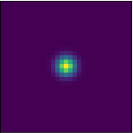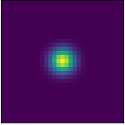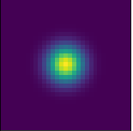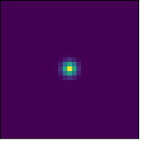

8 LOG (Laplacian of Gaussian) filters with in increasing order row by row from left to right

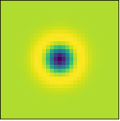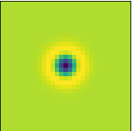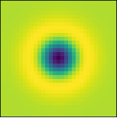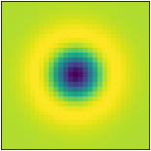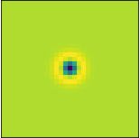

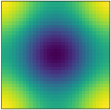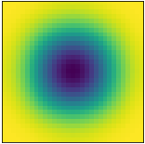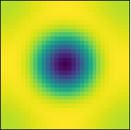

18 *x*-directional first derivation of Gaussian filters with and in three different scales and six different orientations . Each row represents a 30 degree increase in rotation of the standard filter before convolving it with the gaussian and Laplacian filters in increasing order of sigma. Three sigmas and 6 angles = 18 filters.

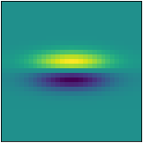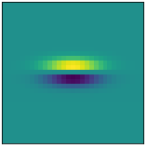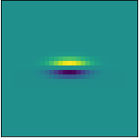

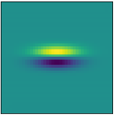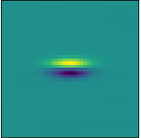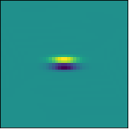

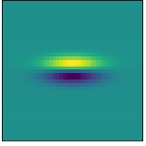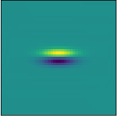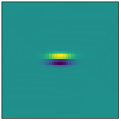

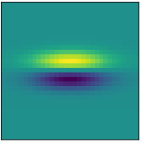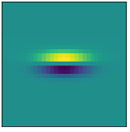

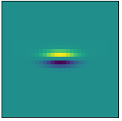

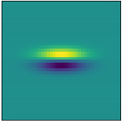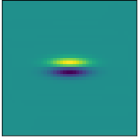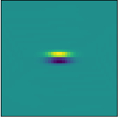

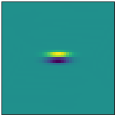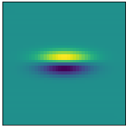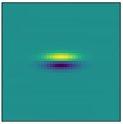

18 *x*-directional second derivation of Gaussian filters with and in three different scales and six different orientations . Each row represents a 30 degree increase in rotation of the standard filter before convolving it with the gaussian and Laplacian filters in increasing order of sigma. Three sigmas and 6 angles = 18 filters.

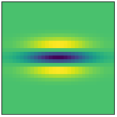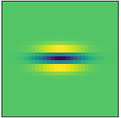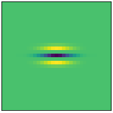

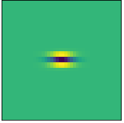

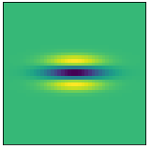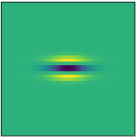

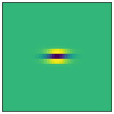

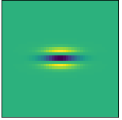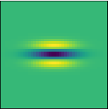

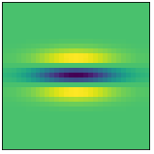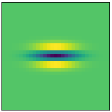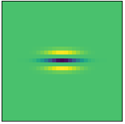

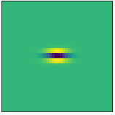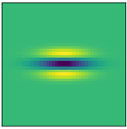

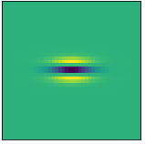

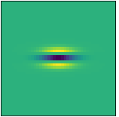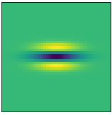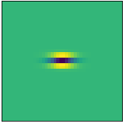

## B. Image Responses

Below are the image responses of panda.jpg and colloseum.jpg after convolution with the above filter bank. The image responses are ordered in the same order as the filters above.

### Panda.jpg

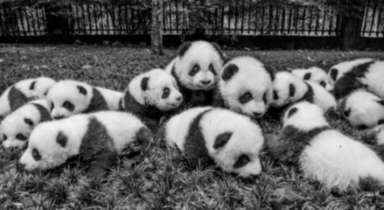Four Gaussian filtered images

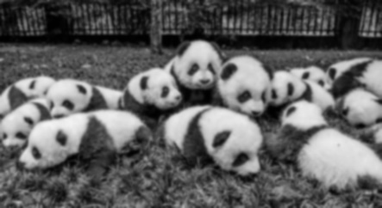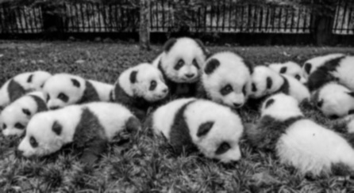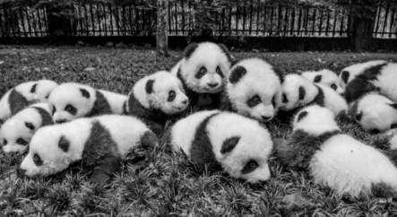

Eight LoG filtered images

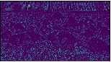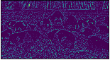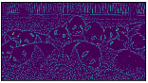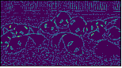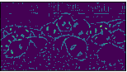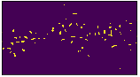

Eighteen x-directional 1st derivate of Gaussian filtered

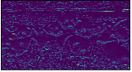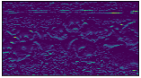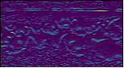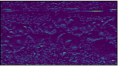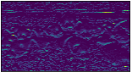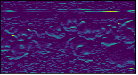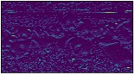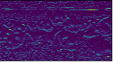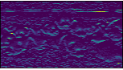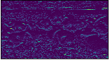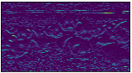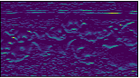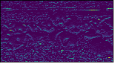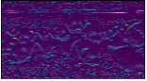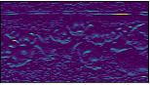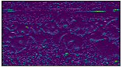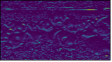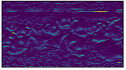

Eighteen x-directional 2nd derivate of Gaussian filtered

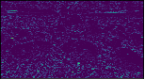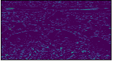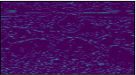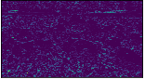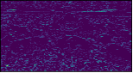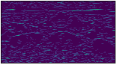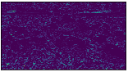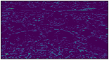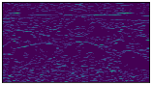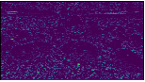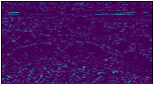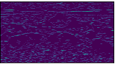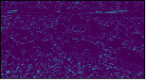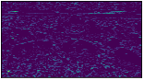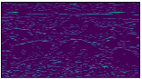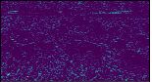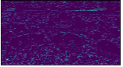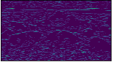

### Colloseum.jpg

Four Gaussian filtered images

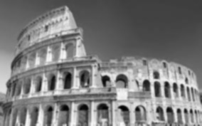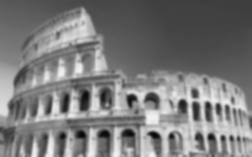

Eight LoG filtered images

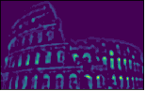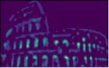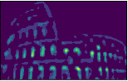

Eighteen x-directional 1st derivate of Gaussian filtered

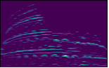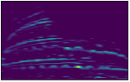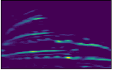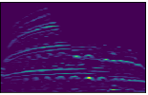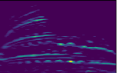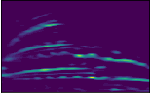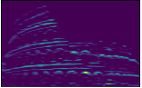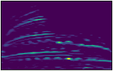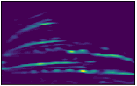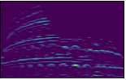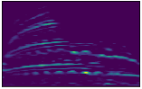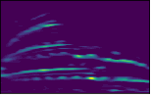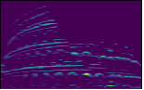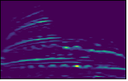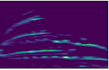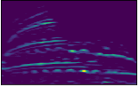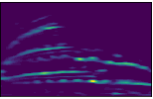

Eighteen x-directional 2nd derivate of Gaussian filtered

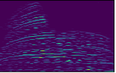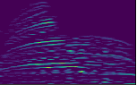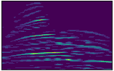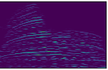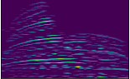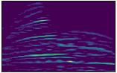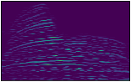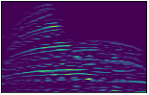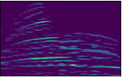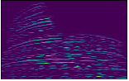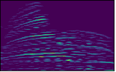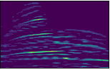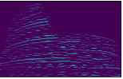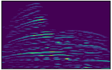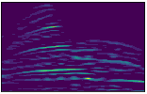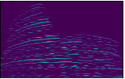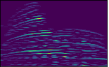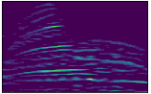

## C. Mean and Variance of filters

### Panda.jpg

Highest Mean – 99.11, Highest Mean Filter – Gaussian filter with sigma 1

Highest Variance – 4727.20, Highest Variance Filter - Gaussian filter with sigma 1

### Colloseum.jpg

Highest Mean – 122.76, Highest Mean Filter - Gaussian filter with sigma 2 * root(2)

Highest Variance – 2561.96, Highest Variance Filter - Gaussian filter with sigma 1

# Part 2

## A. Similarity Scores using Euclidian Distance and Cosine Similarity scores

Euclidian Distance (Lowest distance = most similar)

### Panda.jpg

1. 12.jpg – Distance = 63.30

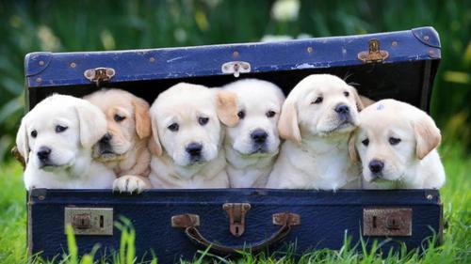

1. 16.jpg – Distance = 469.03

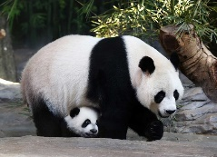

1. 07.jpg – Distance = 958.49



1. 18.jpg – Distance = 2484.72

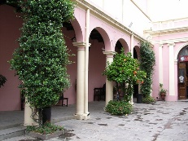

1. 09.jpg – Distance = 2740.31

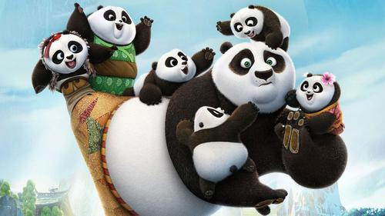

### Colloseum.jpg

1. 00.jpg – Distance = 353.20

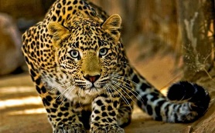

1. 19.jpg – Distance = 454.94

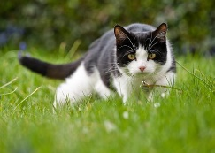

1. 13.jpg – Distance = 553.70

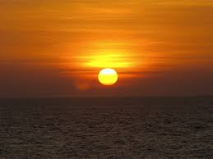

1. 06.jpg – Distance = 596.38

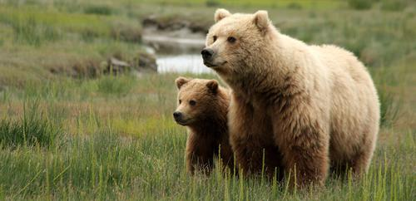

1. 04.jpg – Distance = 778.34

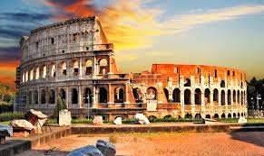

Cosine Similarity (Highest score = high similarity)

### Panda.jpg

1. 12.jpg – Similarity = 0.999981699232577



1. 09.jpg – Similarity = 0.9999783750854213



1. 16.jpg – Similarity = 0.9999497863052128



1. 18.jpg – Similarity = 0.9998585253502229



1. 07.jpg – Similarity = 0.9998198442739132



### Colloseum.jpg

1. 00.jpg – Similarity = 0.9998271220292198



1. 04.jpg – Similarity = 0.9998052543884526



1. 11.jpg – Similarity = 0.9990221730599504

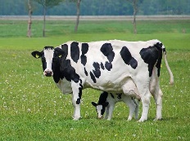

1. 02.jpg – Similarity = 0.9986830343931198

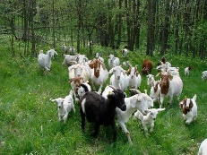

1. 10.jpg – Similarity = 0.9983896692711813

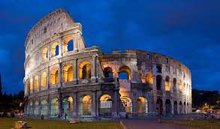

## B. Five Most Similar Images with Color Histogram

Euclidian Distance (Lowest distance = most similar)

### Panda.jpg

1. 16.jpg – Distance = 0.22642380929310496



1. 18.jpg – Distance = 0.5522758150379845



1. 12.jpg – Distance = 0.5818199597904031



1. 09.jpg – Distance = 0.7741281428529166



1. 02.jpg – Distance = 0.8506153451994174



### Colloseum.jpg

1. 18.jpg – Distance = 1.4223737046891245



1. 04.jpg – Distance = 1.4592555229953477



1. 07.jpg – Distance = 1.559816074398412



1. 16.jpg – Distance = 1.5674581833374932



1. 12.jpg – Distance = 1.5951505721163624



Cosine Similarity (Highest score = high similarity)

### Panda.jpg

1. 16.jpg – Similarity = 0.8867880702018738



1. 18.jpg – Similarity = 0.7238621115684509



1. 12.jpg – Similarity = 0.7090900540351868



1. 09.jpg – Similarity = 0.6129359602928162



1. 02.jpg – Similarity = 0.5746923685073853



### Colloseum.jpg

1. 18.jpg – Similarity = 0.28881311416625977



1. 04.jpg – Similarity = 0.2703722417354584



1. 07.jpg – Similarity = 0.22009196877479553



1. 16.jpg – Similarity = 0.21627090871334076



1. 02.jpg – Similarity = 0.20242473483085632



## Conclusion

From the above results of Part 2, we can see that the feature extraction and ranking performs quite well for panda.jpg but not as well for the colloseum.jpg.